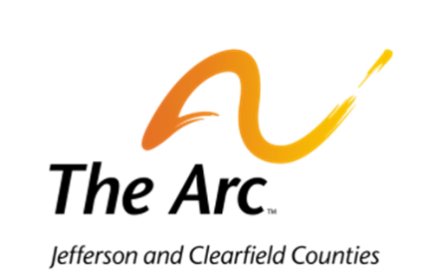
Rental Contract

Company/Name:_______________________________________________________________________

Address:______________________________________________________________________________

Cell Phone:__________________ Home Phone:__________________ Work Phone:_________________

The following facilities are reserved for (date) _________________________________
______Exclusive Camp Rental (entire camp facility, excluding the pond) $100.00 Rental Fee
$50.00 Deposit Total: $150.00
Our/My arrival time will be ____________am/pm on ______________(date).
We/I would like to have Camp Friendship open at _____________am/pm on our event date.
Our/My estimated time of departure is ______________am/pm on ____________ (date).

Note: Deposits are due 30 days in advance of your reservation date. Deposits will be given back at the end of the camp rental if facilities are left in satisfactory condition. Payment in full is due one week in advance of your rental.
Additional donations are always appreciated. All donations go directly back into our summer camping program and the individuals who attend Camp Friendship. $___________ Total Amount Due
$___________ Deposit
$___________ Rental Fee
$___________ Additional Donations
Please make checks payable to: The Arc of Jefferson & Clearfield Counties
Checks should be sent to:
The Arc of Jefferson and Clearfield Counties
Attn: Carla Ferko
PO Box 236
Punxsutawney, PA 15767

I have read and understand the payment fee schedule and agree to make payments in the aforementioned guidelines. By signing this agreement, I acknowledge that I have read and understand both the Rental Contract and the Camp Friendship Rental Policies. Camp Friendship Rental Policies will be shared with all group members. I agree to be the sole person duly authorized to bind the organization or group to this agreement.

________________________________ ___________________________

Renter’s Signature Date

Notice: camp is located at 8 Oven Road Reynoldsville, PA 15851

